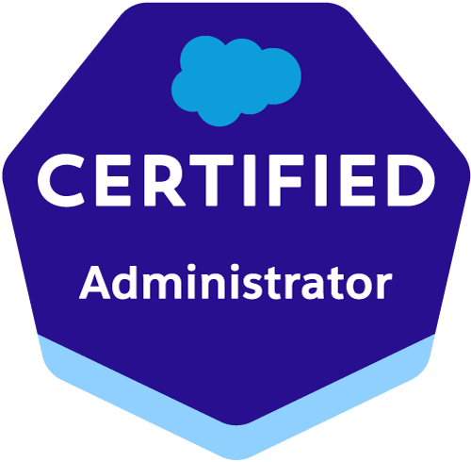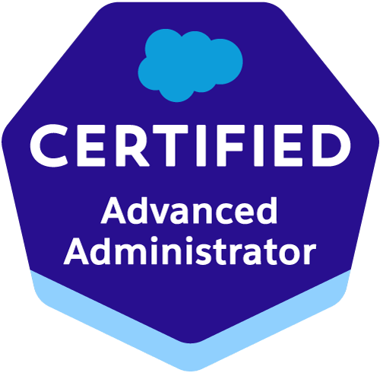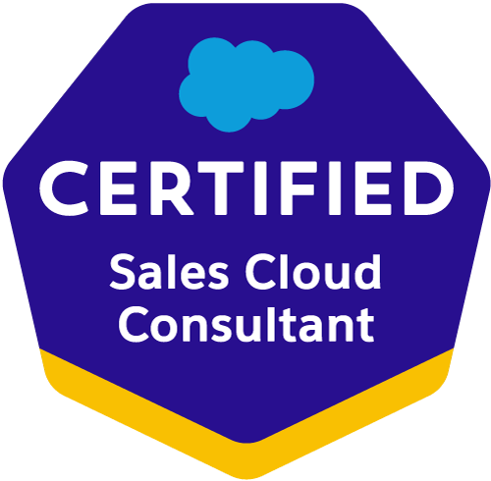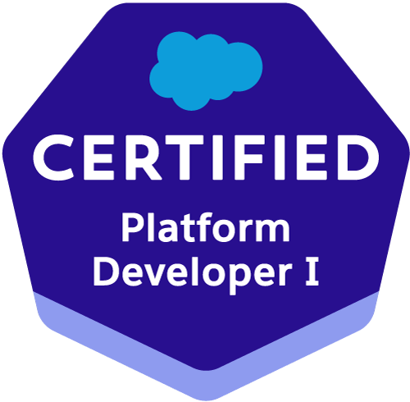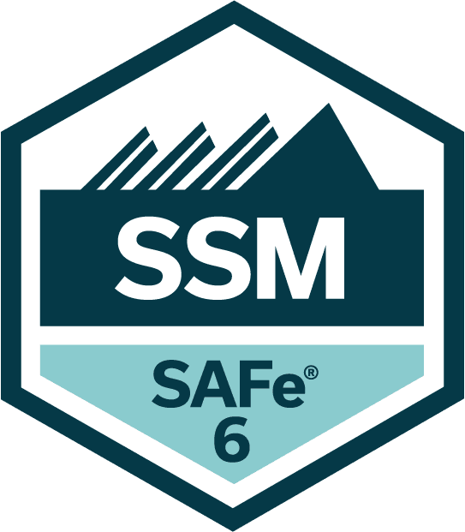
Raghavendra Reddy Akunapuram
EMAIL : salesforcer4@gmail.com |972-945-5309| LinkedIn | TrailHead

SUMMARY

Proficient Salesforce Consultant with 11+ years of experience in analyzing business processes, designing custom Salesforce solutions, and optimizing functionality. Skilled in gathering requirements, conducting gap analysis, configuring Salesforce components, and providing user training and support. Strong collaborator with cross-functional teams, delivering innovative solutions within timelines. Expert in Salesforce best practices, industry standards, and emerging trends. Excellent communication skills for technical and non-technical stakeholders.

TECHNICAL SKILLS

- Salesforce Technologies: Salesforce Service Cloud, Sales Cloud, Experience Cloud, Health Cloud, Veeva CRM, Veeva Vault, Apex (Classes, Triggers, Batch, Queueable, Future Methods, Schedulers), Salesforce Flows, Workflow Rules, Process Builder, Approval Processes, Custom Metadata, Custom Settings, Validation Rules, Sharing Rules, Role Hierarchy, Dashboards, Salesforce Lightning, Security Controls, App-Exchange & Custom Applications.
- Project Management & Methodologies: Agile (Scrum, Kanban), Jira, Confluence, MIRO, Sprint Planning, Feature Grooming, Daily Stand-ups, Code Review, Peer Programming, Best Practices Enforcement.
- Integration & APIs: REST APIs, SOAP APIs, Web Services, Outbound Messages, Field Updates, Custom Labels and Tabs, Email Services.
- Data Management & Tools: Data Loader, Apex Data Loader, SOQL, SOSL, Tableau, Eclipse IDE Plug-in, MKS Source Integrity, Hubspot, Bit Bucket, Workbench, Import Wizard.
- Business Analysis Tools & Concepts: Functional Requirements Documents (FRD), Business Requirements Documents (BRD), System Requirements Specifications (SRS), Cost/Benefit Analysis, Impact Analysis, GAP Analysis, Risk Analysis, SWOT Analysis, Microsoft Visio, Lucid Charts, I-Draw, Swimlane Charts, User Acceptance Testing (UAT) Coordination.
- CRMs & Related Platforms: Steel Brick CPQ, Conga Composer, MH Strategic Selling application, Shopify, Magento, Salesforce Commerce Cloud, Einstein AI, ChatBot, Agent AI.
- DevOps & Version Control: GitHub, Copado, CI/CD, Changesets.
- Compliance & Security: PCI-DSS Compliance, GDPR/Data Privacy Adherence, Fraud Prevention Measures.
- Soft Skills: Leadership Skills, Technical skills, Communication Skills, Analytical, Interpersonal, Problem-Solving Skills

EDUCATION

University of Central Missouri – Warrensburg, MO, USA Jan 2013 – Aug 2014
Master of Science in Computer Science

Jawaharlal Nehru Technological University, Hyderabad, India Aug 2008 – May 2012 Bachelor of Technology in Information Technology

EXPERIENCE

Aetna (CVS), Remote Nov 2025 - Current
Salesforce Business Analyst
- Worked closely with business teams to understand how they sell, support customers, and manage data, then translated those needs into clear Salesforce requirements
- Ran workshops and one on one sessions with stakeholders to gather requirements and document user stories and acceptance criteria
- Partnered with Salesforce Admins and Developers to design practical solutions in Sales Cloud and Service Cloud
- Led User Acceptance Testing sessions, tracked defects, and ensured issues were resolved before go live.
- Created dashboards and reports to give leadership clear visibility into pipeline, performance, and service metrics
- Contributed to the Enterprise Salesforce Team by aligning solutions with enterprise architecture standards and shared governance models
- Strengthened requirement traceability from intake through deployment, reducing production defects and rework
- Supported platform enhancements serving multiple business units, ensuring consistent data models, security frameworks, and automation standards
- Supported integrations between Salesforce and external enterprise systems such as ERP, marketing platforms, and data warehouses
- Participated in large scale release planning and cross functional coordination to support enterprise-wide deployments

Environment: Salesforce Sales Cloud, Apex, Flows Visualforce Pages, REST APIs, SOQL, SOSL, Data Loader, Workbench, Agile, SCRUM, MIRO, Tableau, Lightning Components.

Viewrail , Remote Oct 2024 – Oct 2025
Lead Salesforce Consultant
- Collaborated with stakeholders (marketing, product, IT, and vendors) to gather business requirements for e-commerce platforms (e.g., Shopify, Magento, Salesforce Commerce Cloud). Translated business needs into functional specifications, user stories, and process flows.
- Led cross-functional teams in Agile/Scrum ceremonies (sprint planning, backlog grooming) to deliver features like one-click checkout, personalized search, and dynamic pricing.
- Led API integrations for third-party services (e.g., payment gateways, shipping carriers, tax calculators) to automate workflows and reduce manual errors.
- Partnered with tech teams and external vendors to implement solutions (e.g., headless commerce, AI chatbots) while ensuring alignment with business goals.
- Identified AI use cases for product recommendations, support chat automation, and cart behavior insights.
- Conducted competitive benchmarking and market research to identify industry trends (e.g., mobile commerce, social commerce) and recommended feature enhancements to maintain competitive edge.
- Logged architecture notes, flows, and key decisions in Confluence for future AI enhancements.
- Ensured PCI-DSS compliance, GDPR/data privacy adherence, and fraud prevention measures in collaboration with legal and IT security teams.
- Managed project timelines and tracked progress using Jira, ensuring timely resolution of issues and maintaining alignment with project goals.
- Utilized Confluence to document and share project plans, updates, and key decisions, enhancing transparency and communication across the team.

Environment: Salesforce Marketing Cloud, Sales Cloud, Apex, Visualforce Pages, REST APIs, SOAP APIs, HubSpot, Einstein AI, SOQL, SOSL, Data Loader, Workbench, Agile, SCRUM, MIRO, Tableau.

Amgen – CA Jan 2019 – Sept 2024
Sr. Salesforce Analyst

- Managed and delivered complex projects leveraging Agile and Scrum methodologies, consistently meeting timelines and exceeding stakeholder expectations.
- Extracted and analyzed critical business data using SQL, identifying key trends and patterns that significantly enhanced strategic decision-making processes.
- Boosted team productivity by leveraging MS SharePoint and MIRO for efficient document management and collaborative workflow.
- Gathered and analyzed detailed business requirements from stakeholders, translating them into robust functional specifications and technical requirements for Salesforce implementation, including specialized Health Cloud features (care plans, care team assignments, patient timeline).
- Conducted in-depth gap analysis between legacy healthcare systems and Salesforce Health Cloud, leading to a 25% increase in workflow efficiency.
- Led an end-to-end migration from MS Dynamics CRM to Salesforce Sales Cloud, partnered with business and IT teams to understand real-world workflows, cleaned and migrated over 1M records, rebuilt critical automations and reports, supported user training and go-live, and helped cut manual work by 30 percent while improving data quality and user confidence.
- Defined expected AI outcomes with business teams to support measurable value for clinical and commercial groups.
- Supported Agent AI readiness with process maps, data quality reviews, and documentation of logic.
- Managed project timelines and tracked progress using Jira, ensuring timely issue resolution and alignment with project goals.
- Utilized Confluence for comprehensive documentation of project plans, Health Cloud configurations, and key decisions, fostering transparency across clinical and IT teams.
- Configured Veeva CRM modules, including Approved Email and CLM (Closed Loop Marketing), to align with business objectives and compliance standards.
- Assisted in the integration of Veeva CRM with other enterprise systems, ensuring seamless data flow and reporting capabilities.
- Collaborated effectively with cross-functional teams (developers, administrators, project managers) to ensure seamless integration of Salesforce features.
- Conducted in-depth analysis of Veeva CRM functionalities to identify opportunities for process improvement and data accuracy.
- Managed Salesforce CRM configurations, including custom objects, page layouts, workflows, and validation rules, to precisely meet evolving business needs.
- Led the development and configuration of intricate Salesforce Reports and Dashboards, tailored to streamline vendor operations and daily activities.
- Collaborated closely with business stakeholders to formulate and manage Service Level Agreements (SLAs), defining Key Performance Indicators (KPIs), ensuring application stability, and identifying opportunities for automation and efficiency.
- Designed and maintained Territory Alignment Reports (TAR) on the Tableau platform for Field Sales and Internal teams across various Engagement Programs.

Environment: Veeva CRM, Veeva Vault, Salesforce Service Cloud, Marketing Cloud, Health Cloud, REST APIs, SOAP APIs, SOQL, SOSL, Copado, CI/CD, Data Loader, Workbench, Import Wizard, Agile, Changesets, Agent AI, Confluence, JIRA, MIRO

HSF Affiliates – CA Oct 2018 - Jan 2019
Salesforce Consultant

- Prepared comprehensive Functional Requirements Documents (FRD), Business Requirements Documents (BRD), and System Requirements Specifications (SRS), ensuring 100% accuracy and alignment with business objectives.
- Developed and executed complex SQL queries for thorough data analysis and test result validation.
- Applied cost/benefit analysis, impact analysis, GAP analysis, risk analysis, and SWOT analysis, leading to a 30% improvement in strategic decision-making accuracy.
- Utilized tracking tools such as Jira, Microsoft Visio, and HP Quality Center to facilitate project tracking, documentation, and collaboration.
- Played a pivotal role in tailoring Salesforce functionalities to meet specific business requirements, including customization of workflows, approval processes, role setup, profile creation, security controls, and data management strategies.
- Created detailed project plans, timelines, and resource allocations for Salesforce implementation projects, ensuring timely delivery and within budget.
- Established lookup and master-detail relationships between objects and implemented junction objects to facilitate seamless connectivity among different entities.
- Orchestrated the creation of users, roles, territories, and public groups, while implementing role hierarchies, sharing rules, and record-level permissions to ensure appropriate shared access across diverse user groups.
- Designed and configured various Reports and Report Folders tailored to the needs of different user profiles within the organization.

Environment: Portal Pages, Salesforce Service Cloud, Marketing Cloud, Apex, Visualforce Pages, REST APIs, SOAP APIs, SOQL, SOSL, GitHub, Data Loader, Workbench, Import Wizard, Agile, Changesets

eCamSecure – CA Jan 2017 - Sep 2018
Salesforce Consultant
- Heavily involved in customizing Salesforce functionalities including Workflow rules, Flows, approval process, role setup, profile creation, and security controls.
- Developed on Visualforce Pages, Apex Classes, Visualforce Custom Controllers Components, Advanced Search Functionality, Dashboards, Custom Objects, Custom Reports, Custom Tabs, Tags and Components.
- Led and managed the implementation of Salesforce Omni Studio to enhance customer service experience in the travel industry.
- Prepared detailed workflows and various custom reports for different business levels, and provided essential user training to internal business users on Salesforce platform utilization.
- Worked extensively with Sales Cloud, managing Accounts, Contacts, Cases, and solutions to drive business development.
- Created workflow rules and defined related tasks, time-triggered tasks, email alerts, field updates, and web services to implement robust business logic.
- Integrated Steel Brick CPQ related configurations for product setup, approval rules, process builders, and flows.
- Implemented and managed Conga Composer, developing templates to effectively present quotes with diverse product offerings.
- Engineered a tailored Round Robin process within Salesforce, streamlining lead assignment for both inside and outside sales representatives.
- Provided comprehensive support and adept troubleshooting for any challenges encountered within the Salesforce environment.

Environment: Sales Cloud, Apex, Visualforce Pages, SteelBrick CPQ, REST APIs, SOAP APIs, HubSpot, SOQL, SOSL, Data Loader, Workbench, Import Wizard, Agile, Changesets, JIRA, Confluence

Terumo BCT – CO Jan 2016 - Nov 2016
Sr. Salesforce Developer/Admin
- Developed on Visualforce Pages, Apex Classes, Visualforce Custom Controllers Components, Advanced Search Functionality, Dashboards, Custom Objects, Custom Reports, Analytic Snapshots, Custom Tabs, Tags and Components.
- Created page layouts, search layouts to organize fields, custom links, related lists, and other components on record detail and edit pages.
- Worked on Canvas App in Salesforce for displaying visual BI dashboards.
- Utilized MKS Source Integrity system for storing data from different sandboxes for each release.
- Implemented Miller Heiman Strategic Selling tool, setting up Green, Gold, and Platinum sheets on different Salesforce objects.
- Applied SOQL & SOSL with adherence to Governor Limits for efficient data manipulation using platform database objects.
- Possess strong testing skills in Salesforce1 Mobile App, standard and custom Salesforce objects, fields, page layouts, tabs, and reports.
- Created workflow rules and defined related tasks, time-triggered tasks, email alerts, and field updates to implement business logic.
- Used Lucid Charts, I-draw, and Visio for briefing business process maps and personas, including Swimlane charts to explain processes with different actors.
- Hands-on experience in conducting Joint Application Development (JAD) sessions with End-users, SMEs, Developers, QAs, and other stakeholders.

Environment: Sales Cloud, Apex, Visualforce Pages, REST APIs, SOAP APIs, HubSpot, Canvas App, Miller Heiman Strategic Selling tool, SOQL, SOSL, GitHub, Data Loader, Workbench, Import Wizard, Agile, Changesets.

B2R Finance – NC Aug 2015 - Jan 2016
Salesforce Consultant
- Interacted with various business user groups to gather requirements for Salesforce implementation, thoroughly documenting Business and Software Requirements.
- Spearheaded the conceptualization, development, and deployment of Apex Classes, Visualforce Pages, and Apex Triggers to address diverse functional requirements.
- Applied SQL knowledge to design efficient data models within Salesforce, ensuring optimal data organization, integrity, and scalability.
- Architected and deployed Custom Objects and an Entity-Relationship data model, incorporating validation rules, tab configurations, page layouts, custom tabs, and components.
- Engineered Custom Objects and Reports, configuring Analytic Snapshots for regular data dumps and comprehensive sales performance analysis.
- Created users, roles, territories, public groups and implemented role hierarchies, sharing rules, and record-level permissions to provide shared access.
- Developed interactive dashboards using actions like go-to-sheet, quick filters, and navigations on Tableau using Salesforce Connector.
- Developed and configured various Reports and Report Folders for different user profiles based on organizational needs.
- Configured Workflows to send email alerts, field updates, and other automated actions.

Environment: Sales Cloud, Apex, Visualforce Pages, REST APIs, SOAP APIs, SOQL, SOSL, Custom Settings, Process Builder, Data Loader, Workbench, Import Wizard, Agile, Changesets.

American Express – Phoenix, AZ Aug 2014 - Jul 2015
Salesforce Developer/Admin
- Extensively engaged with Salesforce.com objects such as Opportunities, Products, Cases, Contracts, and Custom Objects, leveraging them to drive business processes effectively.
- Played a pivotal role in configuring Salesforce.com applications to align with the functional requirements of the organization, ensuring seamless integration and optimal performance.
- Applied SOQL and SOSL queries strategically, mindful of Governor Limits, to manipulate data within the platform database objects efficiently.
- Designed and implemented workflow rules, encompassing task assignments, time-triggered tasks, email notifications, and field updates, to enforce business logic and streamline processes.
- Good knowledge in Data Loader to insert, update, and bulk import or export of data from Salesforce.com Objects. Used it to read, extract, and load data from comma separated values (CSV) files.
- Led initiatives to orchestrate marketing campaigns for merchants and card members, focusing on customer retention and acquisition.
- Good knowledge of Salesforce configuration, Data migration, System integration Testing and familiarity with Visualforce (Pages, Components, Controllers) MVC architecture.
- Championed the delivery model involving integrations with various applications within Salesforce and across distributed systems within the AMEX ecosystem.

Environment: Sales Cloud, Apex, Visualforce Pages, REST APIs, SOAP APIs, SOQL, SOSL, Custom Settings, Process Builder, Data Loader, Workbench, Import Wizard, Agile, Changesets.

